**PP LAB WEEK-9**

# DSE VI-A2 Divansh Prasad 210968140

1) Write a program in CUDA to count the number of times a given word is repeated in a sentence.

#include <stdio.h>

#include <stdlib.h>

#include <string.h>

#define MAX_SENTENCE_LENGTH 1000

#define MAX_WORD_LENGTH 100

__global__ void countWordOccurrences(char *sentence, char *word, int *count, int sentenceLength, int wordLength) {

int tid = blockIdx.x * blockDim.x + threadIdx.x;

int wordCount = 0;

if (tid < sentenceLength - wordLength + 1) {

int match = 1;

for (int i = 0; i < wordLength; ++i) {

if (sentence[tid + i] != word[i]) {

match = 0;

break;

}

}

if (match) {

atomicAdd(count, 1);

}

}

}

int main() {

char sentence[MAX_SENTENCE_LENGTH];

char word[MAX_WORD_LENGTH];

int sentenceLength, wordLength;

printf("Enter a sentence: ");

fgets(sentence, MAX_SENTENCE_LENGTH, stdin);

sentenceLength = strlen(sentence);

if (sentence[sentenceLength - 1] == '\n') {

sentence[sentenceLength - 1] = '\0';

sentenceLength--;

}

printf("Enter the word to count: ");

scanf("%s", word);

wordLength = strlen(word);

char *d_sentence, *d_word;

int *d_count;

int count = 0;

cudaMalloc(&d_sentence, sentenceLength * sizeof(char));

cudaMalloc(&d_word, wordLength * sizeof(char));

cudaMalloc(&d_count, sizeof(int));

cudaMemcpy(d_sentence, sentence, sentenceLength * sizeof(char), cudaMemcpyHostToDevice);

cudaMemcpy(d_word, word, wordLength * sizeof(char), cudaMemcpyHostToDevice);

cudaMemcpy(d_count, &count, sizeof(int), cudaMemcpyHostToDevice);

int threadsPerBlock = 256;

int blocksPerGrid = (sentenceLength + threadsPerBlock - 1) / threadsPerBlock;

countWordOccurrences<<<blocksPerGrid, threadsPerBlock>>>(d_sentence, d_word, d_count, sentenceLength, wordLength);

cudaMemcpy(&count, d_count, sizeof(int), cudaMemcpyDeviceToHost);

printf("Number of occurrences of '%s' in the sentence: %d\n", word, count);

cudaFree(d_sentence);

cudaFree(d_word);

cudaFree(d_count);

return 0;

}

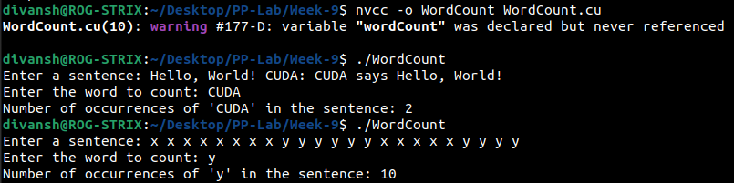

2) Write a CUDA program that reads a string S and produces the string RS as follows:

Input String S: PCAP

Output String RS: PCAPPCAPPCP

Note: Each work item copies the required number of characters from S to RS.

#include <stdio.h>

#include <stdlib.h>

#define MAX_STRING_LENGTH 1000

__global__ void repeatString(char *S, char *RS, int length, int S_length) {

int tid = blockIdx.x * blockDim.x + threadIdx.x;

if (tid < length) {

RS[tid] = S[tid % S_length];

}

}

int main() {

char S[MAX_STRING_LENGTH];

char RS[MAX_STRING_LENGTH * 3]; // Assuming the output string can be at most 3 times the length of the input string

int length;

printf("Enter a string: ");

fgets(S, MAX_STRING_LENGTH, stdin);

length = strlen(S);

if (S[length - 1] == '\n') {

S[length - 1] = '\0';

length--;

}

int S_length = length; // Store the length of input string

length *= 3; // Adjust length for output string

char *d_S, *d_RS;

cudaMalloc(&d_S, S_length * sizeof(char));

cudaMalloc(&d_RS, length * sizeof(char));

cudaMemcpy(d_S, S, S_length * sizeof(char), cudaMemcpyHostToDevice);

int threadsPerBlock = 256;

int blocksPerGrid = (length + threadsPerBlock - 1) / threadsPerBlock;

repeatString<<<blocksPerGrid, threadsPerBlock>>>(d_S, d_RS, length, S_length);

cudaMemcpy(RS, d_RS, length * sizeof(char), cudaMemcpyDeviceToHost);

printf("Input String S: %s\n", S);

printf("Output String RS: %s\n", RS);

cudaFree(d_S);

cudaFree(d_RS);

return 0;

}

